Task:

* Create a VPC, subnet, security group, Key pair and an t2.micro instance using terraform
* The values should be passed as a variable.

Steps:

* First let try hardcoding the values
* **Create a VPC**

|  |
| --- |
| resource "aws_vpc" "test_vpc" {  cidr_block = "10.0.0.0/26"  tags = {  Name = "terraform_vpc"  }  } |

* **Create a subnet in the VPC**

|  |
| --- |
| resource "aws_subnet" "test_subnet" {  vpc_id = aws_vpc.test_vpc.id  cidr_block = "10.0.0.0/26" # 64 ips  availability_zone = "ap-south-1a"  tags = {  Name = "terraform_subnet"  }  } |

* **Create a security group**

|  |
| --- |
| resource "aws_security_group" "test_sg" {  name = "securitygroup1"  description = "Allow http and ssh ports"  vpc_id = aws_vpc.test_vpc.id  tags = {  Name = "terrafrom_securitygroup"  }  ingress {  from_port = "22"  to_port = "22"  protocol = "tcp"  cidr_blocks = ["0.0.0.0/0"]  }  ingress { #allowing http port  from_port = 80  to_port = 80  protocol = "tcp"  cidr_blocks = ["0.0.0.0/0"] #from anywhere  }  egress{  from_port = 0  to_port = 0  protocol = "-1" # any port  cidr_blocks = ["0.0.0.0/0"] # anywhere  }  } |

* **Create Key_pair**  
  Run the below command to generate the public key and store it in a file  
  **ssh-keygen -f terraform_key_pair**

|  |
| --- |
| resource "aws_key_pair" "test_key_pair" {  key_name = "Testing_Key_pair2"  public_key = "${file("terraform_key_pair.pub")}"  tags = {  Name = "terraform_key_pair"  }  } |

* **Create an Instance**

|  |
| --- |
| resource "aws_instance" "test1" {  ami = "ami-00bb6a80f01f03502"  instance_type = "t2.micro"  key_name = "Testing_Key_pair2"  subnet_id = aws_subnet.test_subnet.id  security_groups = [aws_security_group.test_sg.id]  availability_zone = aws_subnet.test_subnet.availability_zone  tags = {  Name = "Terraform-Instance" #this will be name of the ec2 instance  }    } |

* Done  
  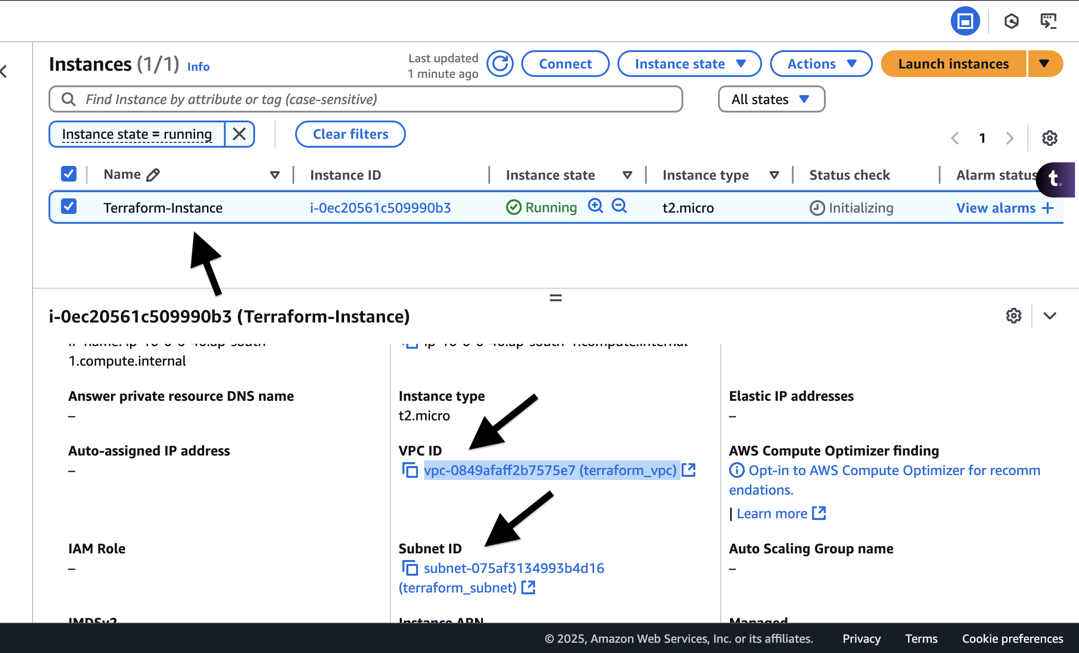  
    
  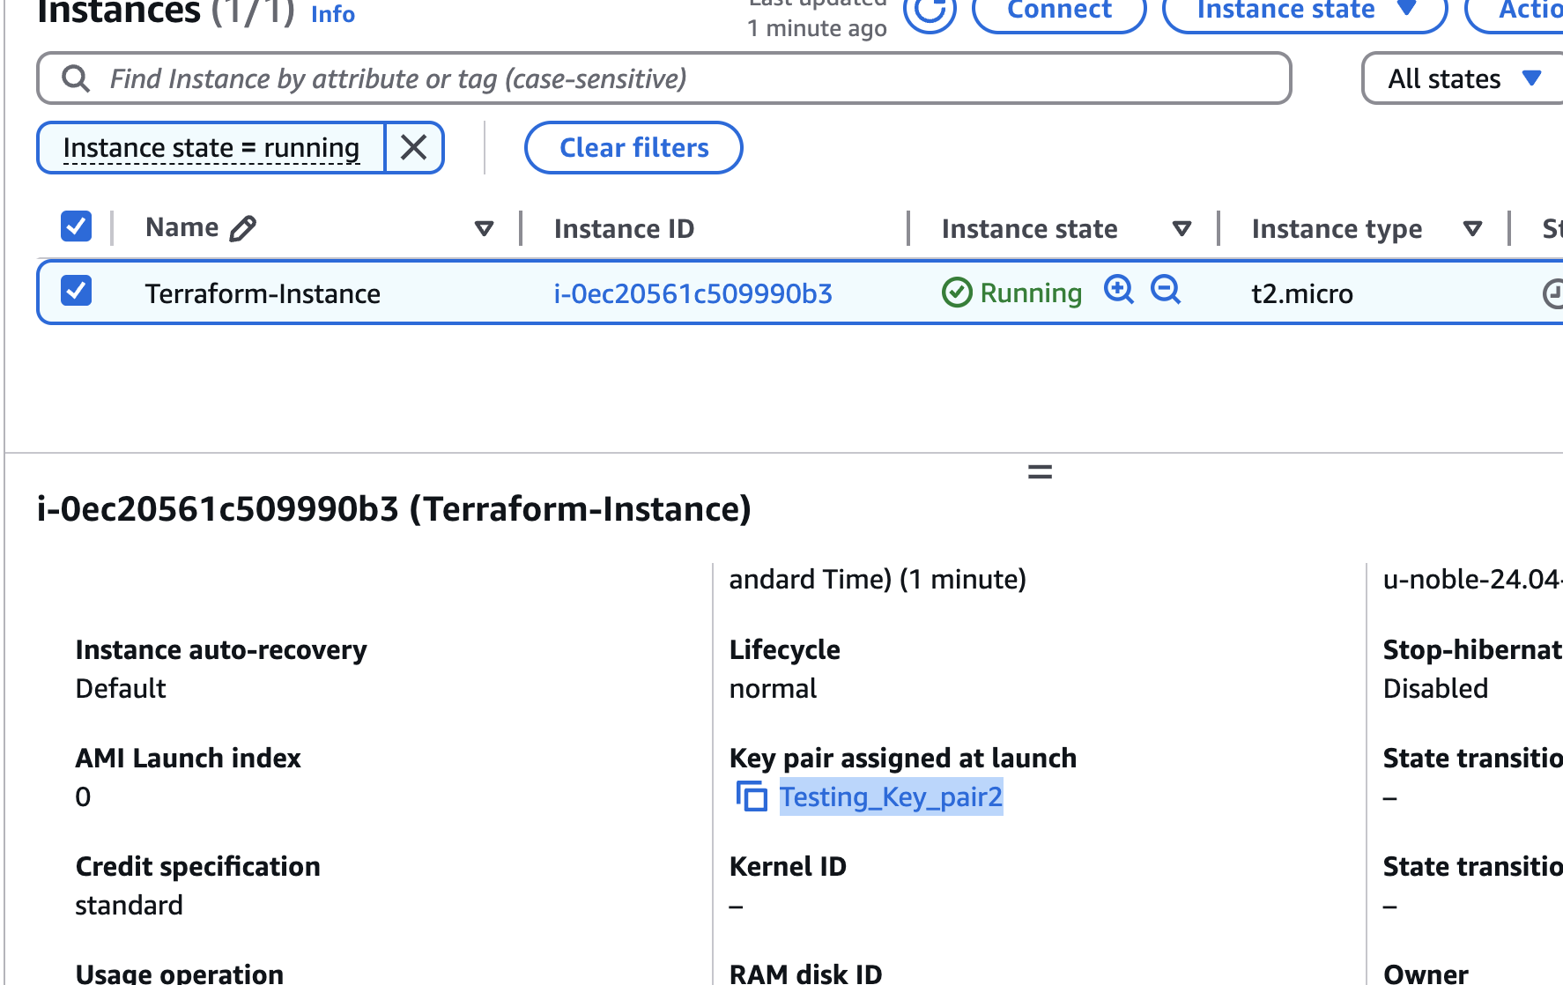  
    
  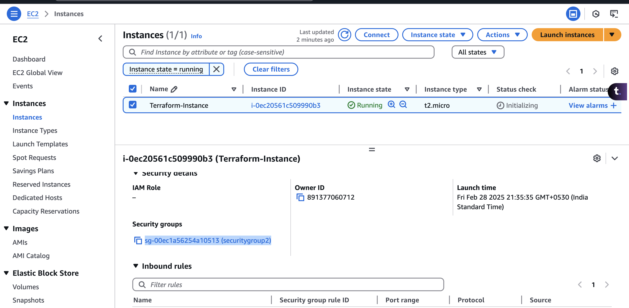
* Now, we need to do the same by using the variables.

Without variable:  
main.tf

|  |
| --- |
| provider "aws" {  region = "ap-south-1"  }  resource "aws_vpc" "test_vpc" {  cidr_block = "10.0.0.0/25"  tags = {  Name = "terraform_vpc"  }  }  resource "aws_subnet" "test_subnet" {  vpc_id = aws_vpc.test_vpc.id  cidr_block = "10.0.0.0/26" # 64 ips  tags = {  Name = "terraform_subnet"  }  }  resource "aws_security_group" "test_sg" {  name = "securitygroup2"  description = "Allow http and ssh ports"  vpc_id = aws_vpc.test_vpc.id  tags = {  Name = "terrafrom_securitygroup"  }  ingress {  from_port = "22"  to_port = "22"  protocol = "tcp"  cidr_blocks = ["0.0.0.0/0"]  }  ingress { #allowing http port  from_port = 80  to_port = 80  protocol = "tcp"  cidr_blocks = ["0.0.0.0/0"] #from anywhere  }  egress{  from_port = 0  to_port = 0  protocol = "-1" # any port  cidr_blocks = ["0.0.0.0/0"] # anywhere  }  }  resource "aws_key_pair" "test_key_pair" {  key_name = "Testing_Key_pair2"  public_key = "${file("terraform_key_pair.pub")}"  tags = {  Name = "terraform_key_pair"  }  }  resource "aws_instance" "test1" {  ami = "ami-00bb6a80f01f03502"  instance_type = "t2.micro"  key_name = "Testing_Key_pair2"  subnet_id = aws_subnet.test_subnet.id  security_groups = [aws_security_group.test_sg.id]  tags = {  Name = "Terraform-Instance" #this will be name of the ec2 instance  }    } |

* With Variables:  
  **main.tf**

|  |
| --- |
| provider "aws" {  region = var.default_region  }  resource "aws_vpc" "test_vpc" {  cidr_block = var.vpc_block  tags = {  Name = var.vpc_name  }  }  resource "aws_subnet" "test_subnet" {  vpc_id = aws_vpc.test_vpc.id  cidr_block = var.subnet_block  availability_zone = var.availability_zone  tags = {  Name = var.subnet_name  }  }  resource "aws_security_group" "test_sg" {  name = var.security_groups_group_name  description = var.security_groups_desc  vpc_id = aws_vpc.test_vpc.id  tags = {  Name = var.security_groups_name  }  ingress {  from_port = var.ssh_port  to_port = var.ssh_port  protocol = var.protocol  cidr_blocks = var.traffic_from_anywhere  }  ingress { #allowing http port  from_port = var.http_port  to_port = var.http_port  protocol = var.protocol  cidr_blocks = var.traffic_from_anywhere #from anywhere  }  egress{  from_port = var.to_from_port  to_port = var.to_from_port  protocol = var.any_protocol # any port  cidr_blocks = var.traffic_from_anywhere # anywhere  }  }  resource "aws_key_pair" "test_key_pair" {  key_name = var.key_name  public_key = "${file("terraform_key_pair.pub")}"  tags = {  Name = var.key_pair_name  }  }  resource "aws_instance" "test1" {  ami = var.ami_id  instance_type = var.instance_type  key_name = var.key_name  subnet_id = aws_subnet.test_subnet.id  security_groups = [aws_security_group.test_sg.id]  availability_zone = aws_subnet.test_subnet.availability_zone  tags = {  Name = var.instance_name #this will be name of the ec2 instance  }    } |

**variables.tf**

|  |
| --- |
| variable "default_region" {  default = "ap-south-1"  description = "The default region"  }  variable "availability_zone" {  default = "ap-south-1a"  }  variable "vpc_block" {  default = "10.0.0.0/25"  description = "CIDR block"  }  variable "vpc_name" {  default = "default_VPC"  description = "Name of the VPC"  }  variable "subnet_block" {  default = "10.0.0.0/25"  description = "CIDR block of the subnet"  }  variable "subnet_name" {  default = "default_VPC"  description = "Name of the VPC"  }  variable "security_groups_group_name" {  default = "launch-wizard-1"  description = "security group name"  }  variable "security_groups_desc" {  default = "Allow http and ssh ports"  description = "security group name description"  }  variable "security_groups_name" {  default = ""  description = "security group name"  }  variable "ssh_port" {  default = "22"  description = "SSH port"  }  variable "http_port" {  default = "80"  description = "HTTP port"  }  variable "protocol" {  default = "tcp"  description = "tcp protocol"  }  variable "to_from_port" {  default = "0"  }  variable "any_protocol" {  default = "-1"  description = "tcp protocol"  }  variable "traffic_from_anywhere" {  default = ["0.0.0.0/0"]  description = "Allow traffic from anywhere"  }  variable "key_name" {  default = "Testing_Key_pair2"  description = "Key name"  }  variable "key_pair_name" {  default = "terraform_key_pair"  description = "Key pair name"  }  variable "ami_id" {  default = "ami-00bb6a80f01f03502"  description = "AMI id"  }  variable "instance_type" {  default = "t2.micro"  description = "The EC2 instance type"  }  variable "instance_name" {  default = "Terraform-Instance"  description = "Name of the instance"  } |

**terraform.tfvars**

|  |
| --- |
| vpc_name = "terraform_vpc"  subnet_name = "terraform_subnet"  security_groups_group_name = "securitygroup2"  security_groups_name = "terrafrom_securitygroup" |



